Lab C - Phishing Detection

Timothy Victori

Arizona State University

IFT 202

Gary Grindle

9/7/2024

Part 1
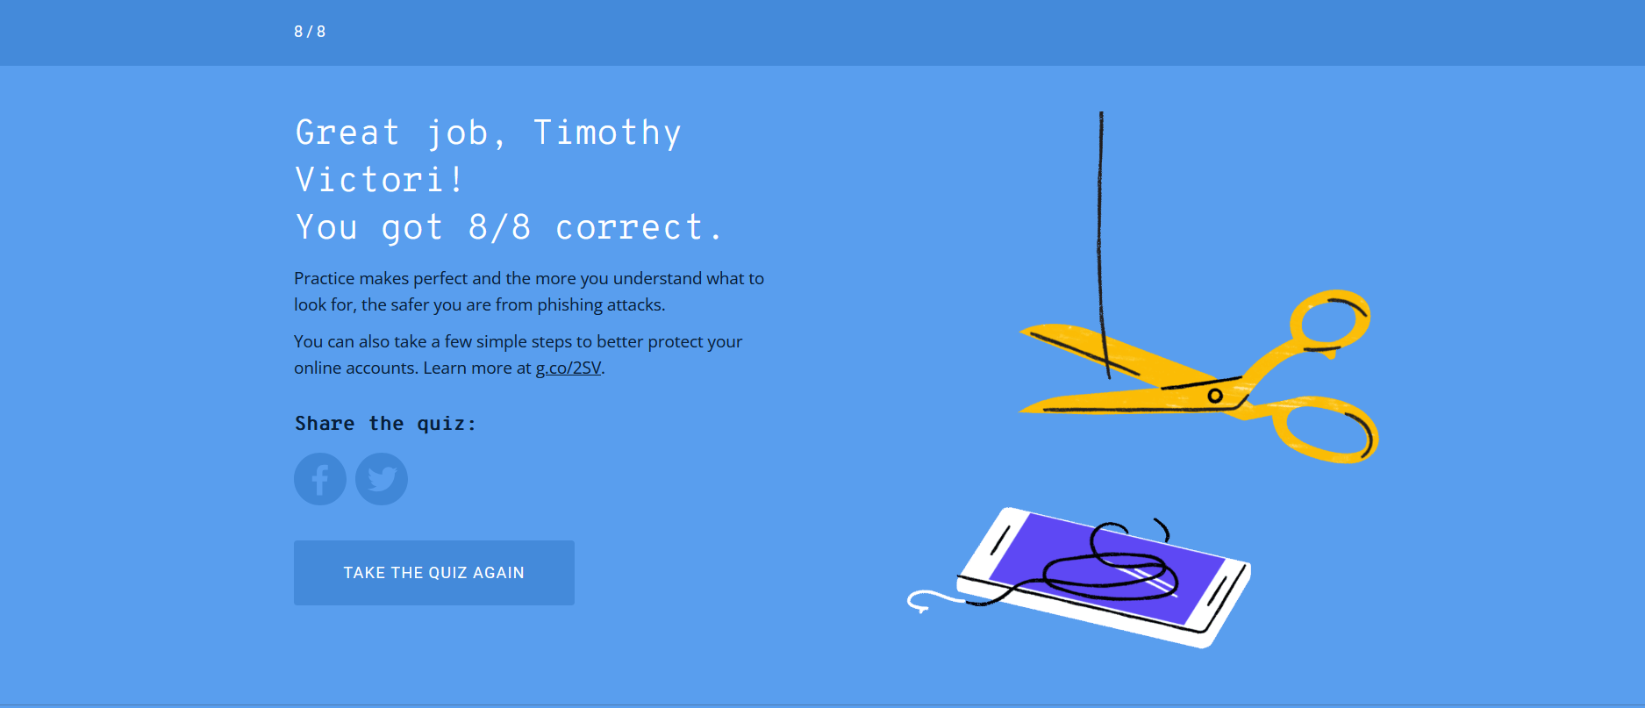
Part 2
- spf=fail (sender IP is 148.163.148.157)
- Fail (protection.outlook.com: domain of microsoft.com
- eric.bishop@asu.edu
- "Microsoft Security Center" <security@microsoft.com>
- security@microsoft.com
- security@microsoft.com
- Apple Mail
- <20220929014213.576E060956D@emkei.cz>
- URLs
  - https://urldefense.com/v3/__h=ttp://security.microsoft.passwordreset.ru__;!!IKRxdwAv5BmarQ!dGKnZQ4Ti_P11h=i2DcfOAsHJ-0kFXiT8lcLMIX7uDLzvCqTaVJaWsr-s4mQSiHMl4f1kdLTYzLXuiaKUGJeM$ (Reset your password URL)
  - https://urldefense.com/v3/__http://security.microsoft.passwo=rdreset.ru__;!!IKRxdwAv5BmarQ!dGKnZQ4Ti_P11hi2DcfOAsHJ-0kFXiT8lcLMIX7uDLzvC=qTaVJaWsr-s4mQSiHMl4f1kdLTYzLXuiaKUGJeM$
(Review your security URL)
  - https://urldefense.com/v3/__http://security.microsoft.passwo=rdreset.ru__;!!IKRxdwAv5BmarQ!dGKnZQ4Ti_P11hi2DcfOAsHJ-0kFXiT8lcLMIX7uDLzvC=qTaVJaWsr-s4mQSiHMl4f1kdLTYzLXuiaKUGJeM$
(Learn how to make your account more secure URL)
  - https://urldef=ense.com/v3/__http://security.microsoft.passwordreset.ru__;!!IKRxdwAv5BmarQ=!dGKnZQ4Ti_P11hi2DcfOAsHJ-0kFXiT8lcLMIX7uDLzvCqTaVJaWsr-s4mQSiHMl4f1kdLTYzL=XuiaKUGJeM$
(here URL)
- Phishing
- The URLS use the domain name “urldefense.com” as opposed to the pure link to security.microsoft.com and uses a passwordreset.ru subdomain that is atypical for Microsoft. Mail was sent from a Russian as the spoofed site uses the .ru subdomain pphosted.com seems to be the most likely culpret

